Initial report

**Project name :** Guiders Hub

**Name:** Colleen McConnell

**Student Number:** B00637513

**Project mentor:** Dr Fiona Browne

**Course:** Computer Science

**Date:** 11/10/2016

**1 Introduction**

*1.1 Project background*

Girl guides is a scouting organisation for girls and women. It is quite similar to the boys scouting programmes and it is also a worldwide organisation, running in 145 countries. It is the largest voluntary organisation in the world. Within the UK there are a number of different guiding organisations that are running in local communities.

Our guiding organisation that is operating within Northern Ireland is CGI (Catholic guides of Ireland). They have a number of local units situated all over Ireland and these units are set up for the girls and young women in the community. The Guiders Hub will be a web resource for one local unit situated in West Belfast. The girl guides run a number of programs and activities to help with the development of a young person. They take part in summer camps and other outdoor activities, so it is essential that the parents have all details about the activity and its location. Throughout the year they have a number of fundraising events and ceremonies such as award nights and enrolments where members are given scarf’s and badges. These events take a lot of organisation and it would be beneficial to share the information with all parents and members so they can confirm attendance.

The units that are situated within the local communities are currently relying on social media and other communication apps to connect members and parents. Examples of these include Facebook, what’s app and text messages. There is no central resource used for communication, which means that information sent out to parents may differ.

Facebook is used to post news and photographs of what is going on in the local guiding unit, but as we are aware not every person is a member of Facebook and only those who have an account are able to access the guides own personal profile. Meaning parents will miss out on news and events. The local units Facebook page is set to private so non-members can gain access, as there are 1.71 billion Facebook users currently active in 2016. (Statista, 2016). Therefore, personal or sensitive information relating to the local unit will not be seen by users who are not friends of the page.

Many parents have not grown up in the era of the smart phone so many may not have access to any device or are familiar with current apps. For example, face book messenger and what’s app. Therefore, those who have no access to such apps are already excluded from this form of communication.

Any paper based documents being sent to parents and members such as news articles and weekly updates have their disadvantages. Using copious amounts of paper is harmful to the environment, which goes against the guides ethical contract. One of the main disadvantages with the guides using a paper based system is the lack of storage. The area in which they store their records and permission slips etc, are very poorly organised. Therefore, if anyone needs extra copies about events, then the leader, who is in charge of typing up the documents, has to go home and search for that particular item on their pc. Which is very time consuming epically because they are quite busy with their everyday goings on. The guides rely on funding and fundraising for money to keep the place running. Paper, printers and stationary can be very costly, this money could be spent elsewhere that would benefit the young people more.

*1.2 Current research and developments in this field:*

Web applications are predominantly used for social Media networking sites. (GoodWorkLabs: Mobile App and Software Product Development 2016, 2016)

On Google Play store, there are two mobile applications associated with girl guides and scouts. These applications are share very few similarities with the girl guiding communication web application. Neither of wish addresses the current communication problem. The features of the Girl guiding Canada application include a badge tracker, payment of registration and calendar features. (Girl Guides of Canada, 2016)[4] This applications primary audience is members of the organisation who are working on achieving badges.

The other available mobile application was world association of girl guides and girl scouts. This application is categorised as travel; the application provides users with information about the organisation as well as showing places of interest within London. This application targets members who are visiting London to see one of the World headquarters for girl guides. [5]

There are also online websites associated with girl guiding, an example of these are online guide manager and compass. The online guide manager is a website made specifically for leaders, for record keeping. Users of the site can manage things such as finances, badge records and events. It also allows users to communicate to one another. Although the problem with this web application is that, it is restricted to leaders, leaving out parents and other members. Compass is a similar website that is set up for the scouting association.

Another application that is used for communication is SendHub, this application is mainly used for businesses but it can be applied to groups as well. This application has many communication features such as SMS, file transferring and voice calls. See appendix. [3]

Slack allows users to create channels to organise conversations, it is used for many different purposes. An interesting feature of slack is that it allows the user to create private channels for sensitive information. It also allows users to direct message over users in a secure way.

|  |  |  |  |  |  |  |
| --- | --- | --- | --- | --- | --- | --- |
|  | Features | | | | | |
| Applications | Login | Communication | Gallery | Event page | News feed | Personal profiles |
| World association of girl guides and girl scouts |  |  | x |  |  |  |
| Girl guiding Canada | x |  | x |  |  | x |
| Online guide manager | X | X |  |  |  |  |
| SendHub | x | x |  |  |  |  |
| compass | x | x |  |  |  | x |
| Slack | x | x |  |  |  | x |

1.3 Proposed solution

Guiders Hub web application will fill the current gap in the market. Despite the range of applications catered for the girl guides, none combats the issue of communication. These applications keep records, track progress, and are valuable resources to guiding leaders. Although no application has been developed for all those involved within a guiding organisation such as leaders, parents and members. The Guiders Hub will help save time and energy that leaders would have to spend doing everything manually. (Moreau, 2016) [6]

The Guiders Hub will help users to establish a connection and it will provide tools for users to talk and have conversations. Users will also be able to create and publish their own personal profile, containing some general information about themselves as well as a profile picture. There will be a general news feed in which admin accounts can populate with important updates associated with the goings on of the organisation. The site will also contain a gallery page that will display images of the organisation. There will also be an events section, which will allow users to RSVP.

To gain access to this web application one must first be a registered member of the local girl-guiding organisation. Once registered they will receive a log in account. By doing this, it will mean that unauthorised people who are not members of the organisation will not be able to gain access.

Guiders Hub may contain sensitive information relating to details about children and young people, these groups of people are seen as vulnerable, therefore to insure their safety it is advised to follow a code of ethics. According to (Gotterbarn, Miller, and Rogerson, 1997) there are 8 principles of ethics. One principle talks about the how the software developer will act only in ways that are consistent with the health, safety and welfare of the public. Another principle that applies to the guiders Hub is principle 4.05. This talks about keeping user information private from the public domain. Because there will be sensitive information contained in the Guiders Hub, the website should be fully secure to protect the users.

**2. Project aims and objectives**

2.1 Aim

To develop an online resource that will incorporate all forms of communication together for a local girl-guiding unit. In addition, to create a social hub filled with information and photos for registered members of the organisation.

2.2 Objectives

* Develop a login for registered members. Only those members registered or have a child registered with the local guiding unit will be given access to an account.
* Allow users to see news updates about what is happening within the unit. E.g., News feed.
* Develop away for users to communicate to each other e.g. a chat group.
* Create a gallery of images that will allow uploads.
* Develop an event page were users can create events and RSVP.
* Create a personal profile for users.
* Allow only admin to update the news feed.
* A comment section for users to comment on certain posts.
* Create a database to store user’s login details

**3. Project Plan**

Gantt chart- see appendix

3.2 Risk identification

|  |  |  |
| --- | --- | --- |
|  | Risk | How to avoid risk |
| 1 | Losing work | Keep multiple copies of work. Example external hard drive, pen drive, cloud applications, repositories and local disk drive. |
| 2 | Computer breaks | Keep copies |
| 3 | Working with new software | Read up about the software and practice small projects before its time to implement project. |
| 4 | Internet problems | Find other suitable places to work on project. Example local library, coffee shop, university library Jordanstown and Belfast campus. |
| 5 | Time wasters | Establish what will cost excessive amounts of time and effort. Remove these from project or give a certain amount of time to work on these before moving on. |
| 6 | Other module work | Establish a timetable and give certain days to a subject. |
| 7 | Breaking child protection policies by posting guiding pictures. | Make sure the parents have given permission for their daughters photographs to be shared by the guides. |
| 8 | Working with sensitive information regarding children | Encrypt data in database using AES algorithms and test fully. |
| 9 | Continuous changing requirements | Use waterfall so requirements are established at the start. Explain to stakeholder before agreeing on requirements that no changes can be made. |
| 10 | Unrealistic time estimations | Look at history of assignments an d try to overestimate. |
| 11 | Failure to manage end user expectations | Always keep stakeholder up to date with how the application is going. Ask their opinions on layouts and colours. |
|  |  |  |

Another risk with this web application is security, security is crucial when dealing with any information regarding children. The Guiders Hub will not contain much information regarding the private details of children but it still must be a secure site. To protect sensitive information, the site will be password protected, only members and parents of the Holy Trinity guide unit will be given a login. One way to encrypt the web page will be to use SSL

There is a number of ways to test if the web application is secure for users. Software such as Netsparker will use SQL injection to try to gain access to information, this software is similar to the scripts used by hackers so you can test all know exploits. The automated tests can detect potential vulnerabilities and critical issues. (Gerber and Compton, 2014)

3.3 Software process Model

For this project, the best software development process to use a more traditional approach such as the waterfall method. The Waterfall method is usually used for small-scale projects where the overall time is quite short. In this case, the project will only take 8 months.

The waterfall method is a linear approach to the development of software; the sequences will be as follows: (Lotz, 2013)

1. Requirements
2. Design
3. Coding
4. Testing
5. Maintenance, (gupta, 2013)

This model maybe best suited because the requirements are agreed upon at the start of the project, this also fits in with the final year project because early on in the project there are requirement deadlines were requirements must be met.

There are deadlines set for each stage of development, which coincide with the deadlines set by the university.

With this type of process, it is much easier to measure the progress of work, as the scope of the project is known from the start. As there will be weekly meetings, it will make it much easier to keep track of progress and to report it back to the stakeholders (peer group and mentor). Planning the project will be easier as there are a number of deadlines to meet within this, so the overall time of the project will be known.

The work will be more structured, meaning that one will focus on only one level of the model at a time. Design is normally started early in this model, creating more time for the final report which carries most marks.

3.4 Requirements gathering

To make the web application more appealing to the users it is advised to carry out methods to gather requirements. Requirements gathering can be carried out using interviews and questionnaires. To see which features to add into the application it would be best to speak to parents, leaders and members of the organisation.

References

[1] Taivalsaari, A. (2009) *Mashware*. Available at: https://dl.acm.org/citation.cfm?id=1698213 (Accessed: 11 October 2016)

[2] Statista. (2016). *Facebook users worldwide 2016 | Statista*. [online] Available at: https://www.statista.com/statistics/264810/number-of-monthly-active-facebook-users-worldwide/ [Accessed 11 Oct. 2016].

[3] GoodWorkLabs: Mobile App and Software Product Development 2016. (2016). *Trends and Popularity of Web Application Development Services - GoodWorkLabs: Mobile App and Software Product Development 2016*. [online] Available at: http://www.goodworklabs.com/trends-and-popularity-of-web-application-development-services/ [Accessed 11 Oct. 2016].

[4]Girl Guides of Canada (2016) *Girl guides of Canada – Android Apps on Google play*. Available at: https://play.google.com/store/apps/details?id=com.ggc.moble.app&hl=en_GB (Accessed: 13 October 2016).

[5] GuestU (2016) *World Assoc.Girl Guides/Scouts*. Available at: https://play.google.com/store/apps/details?id=com.xtourmaker.WAGGGS&hl=en_GB (Accessed: 13 October 2016).

[6] Moreau, E. (2016) *Best social media management applications use these social media tools to promote content and manage engagement*. Available at: http://webtrends.about.com/od/pr6/tp/The-Top-10-Social-Media-Management-Applications.htm (Accessed: 14 October 2016).

[7] Lotz, M. (2013) *Waterfall vs. Agile: Which methodology is right for your project?* Available at: http://www.seguetech.com/waterfall-vs-agile-methodology/ (Accessed: 16 October 2016).

[8] gupta, S. (2013) *Software development life cycle model*. Available at: http://blog.oureducation.in/software-development-life-cycle-model/ (Accessed: 16 October 2016).

[9] Gotterbarn, D., Miller, K. and Rogerson, S. (1997) ‘Software engineering code of ethics’, Communications of the ACM, 40(11), pp. 110–118.

[10] Gerber, R. and Compton, T. (2014) ‘10 security tips to protect your website from hackers’, *Creative Blog*, 08 January. Available at: http://www.creativebloq.com/web-design/website-security-tips-protect-your-site-7122853 (Accessed: 11 November 2016).

Appendix

[1]

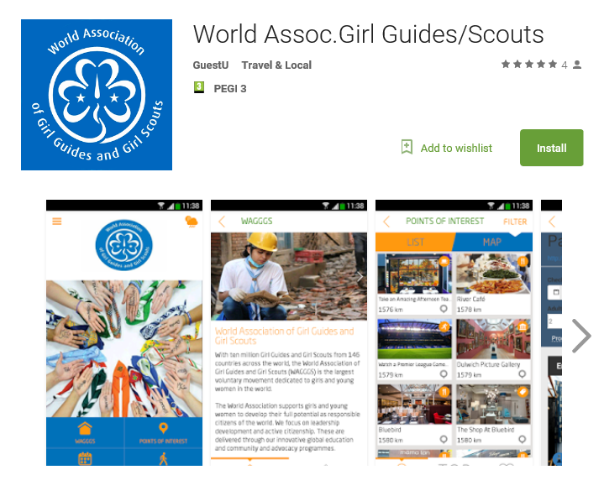

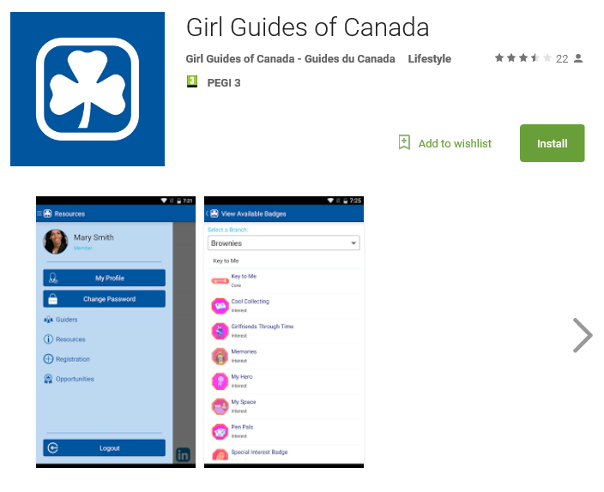[2]

[3]

